# How to install MATLAB NLP

Place the contents of a zip file in a folder on your hard drive for me it is on the root of my C drive. All the functions that we need are in the “nlp lib” subfolder.

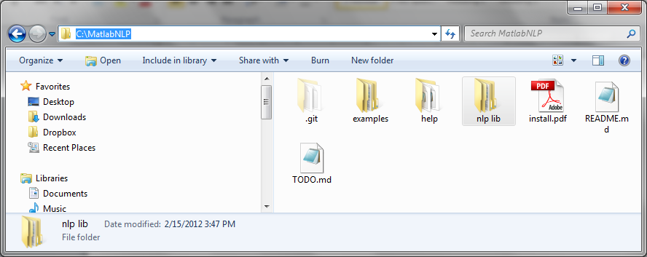

Now you need to add this directory to the path for MATLAB. In Matlab go to the “File” menu and then click on “Set Pat”

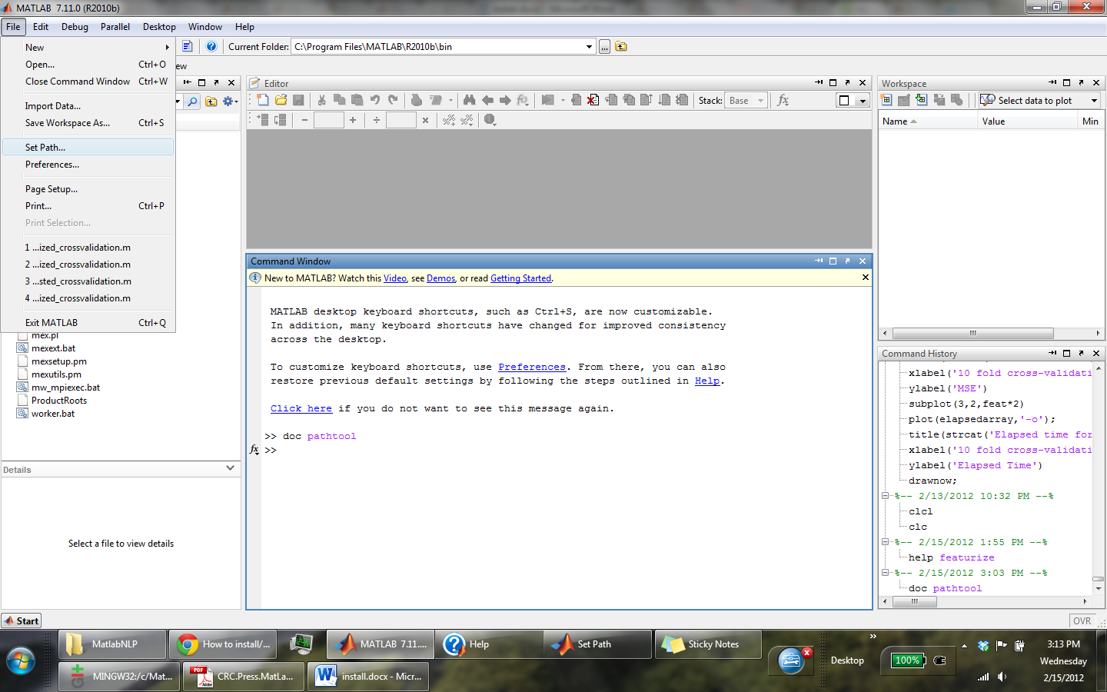

We need to add the “nlp lib” directory to directories that MATLAB used. Your directory to the list of directories in the Matlab path by using file->set path->add folder (or add with subfolders)->save->close

Note: make sure to click on “add with subfolders”

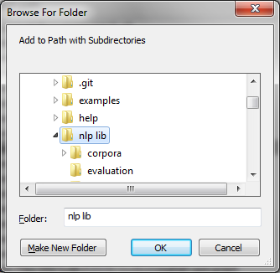

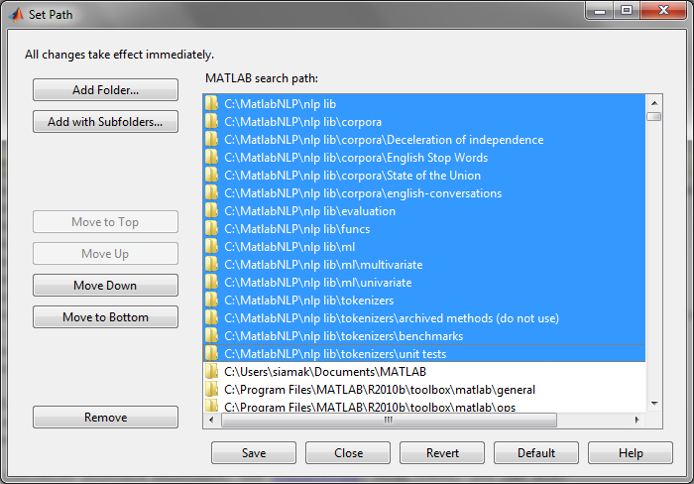

Then save and close Note: In win 7 you may need to have administrator rights to change anything in the MATLAB directory. Run MATLAB as an administrator if that happens

To make sure that the installation was successful in the editor type “help bernoulli” you should see the following

